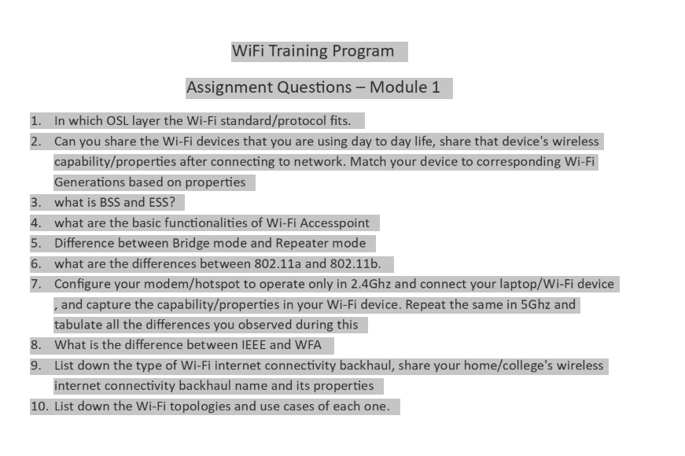

Wi-Fi Training Program
Assignment – 1

1. In which OSI layer the Wi-Fi standard/protocol fits?
Wi-Fi is based on the IEEE 802.11 standard and primarily operates in two layers of the OSI model:
1. Physical Layer (Layer 1)
This layer is responsible for the actual transmission of data over the air using radio waves.
Key functions:
- Defines frequency bands (2.4 GHz, 5 GHz, 6 GHz)
- Handles modulation techniques (OFDM, DSSS, etc.)
- Controls signal strength, data rates, and channel selection
- Converts digital data into radio signals and vice versa

2. Data Link Layer (Layer 2)
This layer ensures reliable communication between devices on the same network.
It is divided into two sublayers:
- MAC (Media Access Control):
  - Controls how devices access the medium (air)
  - Uses MAC addresses for identification
  - Handles collision avoidance using CSMA/CA
- LLC (Logical Link Control):
  - Manages error checking and flow control
Key functions:
- Frame formatting and transmission
- Error detection and retransmission
- Device addressing (MAC address)

2. Wi-Fi devices used in daily life and their capabilities
The following are commonly used Wi-Fi devices and their properties:
Device | Wi-Fi Standard | Frequency Band | Maximum Speed | Features
Smartphone | Wi-Fi 6 (802.11ax) | 2.4 GHz & 5 GHz | ~1.2 Gbps | MU-MIMO, OFDMA
Laptop | Wi-Fi 5 (802.11ac) | 5 GHz | ~866 Mbps | Dual-band support
Smart TV | Wi-Fi 4 (802.11n) | 2.4 GHz | ~300 Mbps | Basic streaming capability
These devices are categorized into Wi-Fi generations based on supported IEEE 802.11 standards.

3. What is BSS and ESS?
BSS (Basic Service Set)
A Basic Service Set (BSS) is the simplest form of a Wi-Fi network.
Components:
- One Access Point (AP)
- Multiple wireless client devices (phones, laptops, etc.)
Characteristics:
- Identified by a BSSID (MAC address of the AP)
- Covers a limited geographical area
- All devices communicate through the AP
Example:
Your home Wi-Fi router with connected devices is a BSS.

Types of BSS
- Infrastructure BSS:
  - Uses an access point
  - Most common (home/office networks)
- Independent BSS (IBSS):
  - Also called Ad-hoc network
  - No access point, devices communicate directly

ESS (Extended Service Set)
An Extended Service Set (ESS) is formed by connecting multiple BSS networks.
Components:
- Multiple Access Points (APs)
- Wired backbone connecting APs
- Same SSID across all APs
Characteristics:
- Allows seamless roaming
- Covers larger areas (offices, campuses)
- Devices automatically switch to the strongest AP
Example:
Wi-Fi in a college campus or large office building.

4. Basic functionalities of a Wi-Fi Access Point
- Provides wireless connectivity to devices
- Connects wireless devices to a wired network
- Manages authentication and encryption (WPA2/WPA3)
- Controls traffic and data flow
- Supports multiple users simultaneously

5. Difference between Bridge Mode and Repeater Mode
Feature | Bridge Mode | Repeater Mode
Function | Connects two networks | Extends existing Wi-Fi
Connection | Wired or Wireless | Wireless only
Performance | Better performance | Reduced performance
Use Case | Network expansion | Coverage extension

6. Difference between 802.11a and 802.11b
Feature | 802.11a | 802.11b
Frequency | 5 GHz | 2.4 GHz
Maximum Speed | 54 Mbps | 11 Mbps
Range | Shorter | Longer
Interference | Less | More

7. Comparison between 2.4 GHz and 5 GHz bands
Feature | 2.4 GHz | 5 GHz
Speed | Lower | Higher
Range | Longer | Shorter
Interference | Higher | Lower
Wall Penetration | Better | Weaker

8. Difference between IEEE and WFA

IEEE (Institute of Electrical and Electronics Engineers)
IEEE is a global professional organization that develops technical standards.
Role in Wi-Fi:
- Defines the 802.11 standards
- Specifies how Wi-Fi works at technical level
- Ensures global standardization
WFA (Wi-Fi Alliance):
Certifies Wi-Fi devices for interoperability and promotes Wi-Fi technology (e.g., Wi-Fi 5, Wi-Fi 6 branding).
The Wi-Fi Alliance is an industry organization that ensures devices work properly together.
Role in Wi-Fi:
- Tests and certifies Wi-Fi devices
- Provides Wi-Fi branding (Wi-Fi 4, 5, 6, etc.)
- Ensures interoperability between devices from different manufacturers
Key functions:
- Certification programs (Wi-Fi CERTIFIED)
- Security standards promotion (WPA2, WPA3)
- Consumer-friendly naming

Key Differences
Feature | IEEE | WFA
Type | Standards organization | Certification body
Role | Develops protocols | Tests & certifies devices
Focus | Technical specifications | User experience & compatibility
Example | 802.11ax | Wi-Fi 6 certification

9. Types of Wi-Fi internet connectivity backhaul
Common backhaul types include:
- Fiber (FTTH): High speed, low latency, highly reliable
- DSL: Moderate speed using telephone lines
- Cable: Broadband via coaxial cables
- Wireless Backhaul: Used in remote or rural areas
Example:
My home network uses Fiber backhaul, providing high-speed internet (~100 Mbps), low latency, and stable connectivity.

10. Wi-Fi topologies and their use cases
Topology | Description | Use Case
Infrastructure | Uses access points for communication | Homes, offices
Ad-hoc | Direct device-to-device connection | Temporary file sharing
Mesh | Multiple interconnected access points | Large areas, campuses

